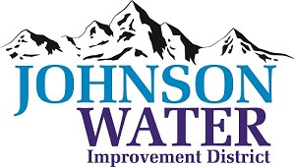
3748 West Highway 87
Roosevelt, UT 84066
Phone (435) 722-2620

August 10, 2023

TO: Board Members

SUBJECT: Board Meeting

Please be reminded that the Regular Board Meeting is Thursday, August 17th at 6:30 p.m.

Agenda:

- Appointments:
  - Jason Blankenagel, Sunrise Engineering ~ Updates on Construction projects

- HR Consultant update.

- Job interview reports

- Operator Report:
  - CKC Firehydrant water tamper fee.
  - Consultant Fee what is JWID going to pay on hourly rate?

- Closed Session: Purpose listed in the Utah Code 52-4-205 (1) (d)

