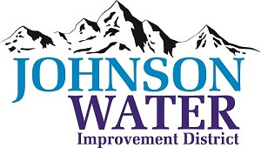
3748 West Highway 87
Roosevelt, UT 84066
Phone (435) 722-2620

March 12, 2024

SUBJECT: Board Meeting

The Regular Board Meeting is Thursday, March 21st at 6:30 p.m.

Agenda:
- Appointments:
  - Ioka Tank alignment – Shiner’s @6:30
  - Jason Blankenagel, Sunrise Engineering ~ Updates on Construction projects
  - Pleasant Valley/Ledge Lane booster station overage on construction cost

- Minutes ~ February 2024
- Financial ~ February 2024

- Open/Close meeting training

- Manager Report:
  - Update on access to the Ioka Tank
  - Independence Connector Project

- Rural Water Conference Report
  - Wetx Discussion
  - Yoppify Discussion

- Personnel Policy update
- Duchesne City Contract counteroffer
- Meter Connection Policy discussion
- Easement on office property
- Tank property realignment

- Old Business

- Closed Session: Purpose listed in the Utah Code 52-4-205 (1) (d)

