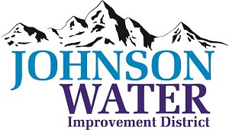
3748 West Highway 87
Roosevelt, UT 84066
Phone (435) 722-2620

September 7, 2023

TO: Board Members

SUBJECT: Board Meeting

Please be reminded that the Public Hearing and Regular Board Meeting is Thursday, September 14th at 6:30 p.m.

Agenda:

- Public Hearing @ 6:30 p.m.

- Appointments:
  - Jason Blankenagel, Sunrise Engineering ~ Updates on Construction projects

- HR Consultant update Banding & Personnel book.
  - Operator position classification discussion.

- Ioka Tank access right of way

- Gulch Crossing “rip rap”

- Manager Report:
  - Policies

- Closed Session: Purpose listed in the Utah Code 52-4-205 (1) (d)

