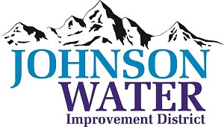

3748 West Highway 87

Roosevelt, UT 84066

Phone (435) 722-2620

July 10, 2024

SUBJECT: Board Meeting

The **Regular Board Meeting** is Thursday, July 18th at 6:30 p.m.

**Agenda**:

1. Appointments:
   1. Ovintiv – Clay Park @6:30 ~ delinquent and projects
   2. Sunrise Engineering ~ Updates on Construction projects
   3. Karl Lamb @7:00 ~ 6250 South water pressure issues
2. Minutes ~ June 2024
3. Financial ~ June 2024
4. Duchesne City Contract
5. Manager Report:
   1. Meter Connection Policy discussion
   2. Rate Study
   3. Sanitary Survey Report
   4. CCR Report
   5. Ledge Lane 10000 West repair
   6. 6250 South update
   7. Independence Tank update
6. Old Business
   1. Employee appreciation barbecue date
7. Closed Session: Purpose listed in the Utah Code 52-4-205 (1) (d)