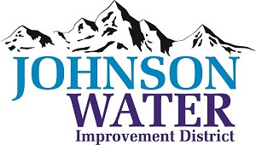

3748 West Highway 87

Roosevelt, UT 84066

Phone (435) 722-2620

June 13, 2024

SUBJECT: Board Meeting

The **Regular Board Meeting** is Thursday, June 20th at 6:30 p.m.

**Agenda**:

1. Appointments:
   1. Jason Blankenagel, Sunrise Engineering ~ Updates on Construction projects
2. Minutes ~ May 2024
3. Financial ~ May 2024
4. Water pressure issues on 6250 South
5. Manager Report:
   1. Meter Connection Policy discussion
   2. Rate Study
   3. Oilfield Water Use
6. Duchesne City Contract
7. Old Business
8. Closed Session: Purpose listed in the Utah Code 52-4-205 (1) (d)