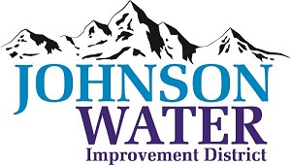

3748 West Highway 87

Roosevelt, UT 84066

Phone (435) 722-2620

March 13, 2025

SUBJECT: Regular Board Meeting

**The Board Meeting** is Thursday, March 20th, at 6:00 p.m.

**Agenda**:

1. We will have Board Training @ 6:00 ~ Rural Water will do the training ~ Board Members come with questions
2. Minutes ~ January 2025
3. Financial ~ February 2025
4. Appointments:
   1. Sunrise Engineering ~ Updates on Construction projects
5. Manager Report:
   1. Kevin Jessen ~ Trailer Park
   2. Recognition at Rural Water Conference
   3. Myton opportunity
6. Master Plan, Capital Improvement, and Specs & Standards ~ Motion approval on cost
7. Tank Cleaning
8. Sub Committee discussion
9. Old Business:
10. Closed Session: Purpose listed in the Utah Code 52-4-205 (1) (d)