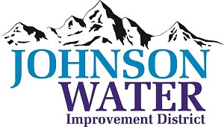

3748 West Highway 87

Roosevelt, UT 84066

Phone (435) 722-2620

September 20, 2024

SUBJECT: Board Meeting

**Board Meeting** is Thursday, September 24th at 6:30 p.m.

**Agenda**:

1. Appointments:
   1. Sunrise Engineering ~ Updates on Construction projects
2. Minutes ~ August 2024
3. Financial ~ August 2024
4. Duchesne City Contract
5. Division of Drinking Water Funding
6. 6250 South ~ Road Crossing
7. Developer Drew Eschler line upgrade
8. Manager Report:
   1. Rate Increase
   2. Water acquisition
9. Old Business:
   1. 4H Booster
10. Closed Session: Purpose listed in the Utah Code 52-4-205 (1) (d)