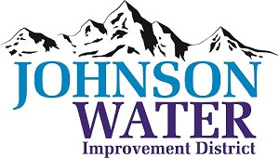

3748 West Highway 87

Roosevelt, UT 84066

Phone (435) 722-2620

August 8, 2024

SUBJECT: Board Meeting

The **Public Hearing and Regular Board Meeting** is Thursday, August 15th at 6:30 p.m.

**Agenda**:

1. Budget Hearing @6:30
   1. Project:

This project involves the replacement of an existing water tank near 5500 E and Independence Rd near Bottle Hollow Reservoir and a pipeline along 1500 E and an additional pipeline along 4000 S in the Independence area.

* 1. Funding – Purpose of this hearing is to address the funding acceptance. Funding package totals $2,950,000 from CIB. The approved funding package includes a $1,711,000 grant and a $1,239,000 loan, 30 years @ 2.0%.

1. Appointments:
   1. Sunrise Engineering ~ Updates on Construction projects
2. Minutes ~ July 2024
3. Financial ~ July 2024
4. Duchesne City Contract
5. Manager Report:
   1. Ledge Lane 10000 West repair update
   2. 6250 South update
6. Old Business:
7. Closed Session: Purpose listed in the Utah Code 52-4-205 (1) (d)