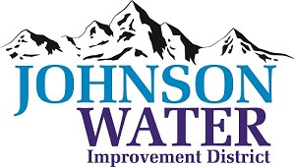

3748 West Highway 87

Roosevelt, UT 84066

Phone (435) 722-2620

May 9, 2024

SUBJECT: Board Meeting

The **Regular Board Meeting** is Thursday, May 16th at 6:30 p.m.

**Agenda**:

1. Appointments:
   1. 2023 Audit @6:30 ~ Cameron Olson, Aycock Miles & Associates
   2. Jason Blankenagel, Sunrise Engineering ~ Updates on Construction projects
2. Minutes ~ April 2024
3. Financial ~ April 2024
4. Manager Report:
   1. Meter inspection project
   2. Karl Lamb loadout discussion
5. Personnel Policy discussion approval
6. Duchesne City Contract counteroffer
7. Meter Connection Policy discussion
8. Old Business
9. Closed Session: Purpose listed in the Utah Code 52-4-205 (1) (d)